Server Side Development

Library Management System

Submitted By: Hinza Noor Amin Mughal (T00203592)

Computing with Software Development

Date Submitted: 11/12/2018

**Table of Contents**

1. Database 3

2. .SQL 3

3. Introduction/Overview 5

4. Elements/Description/Pages 6

# Database

**Name:** WEBLibrary

**Pages:**

1. index.html
2. books.html
3. categories.html
4. members.php
5. rentals.html

# .SQL

**Name:** librarySystem.sql

**Tables:**

* + - 1. Books

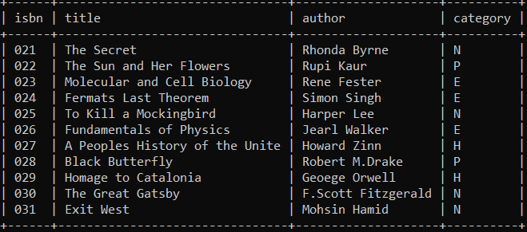

* + - 1. Categories

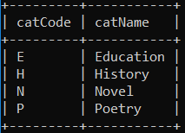

* + - 1. Members

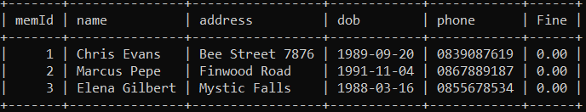

* + - 1. Rentals

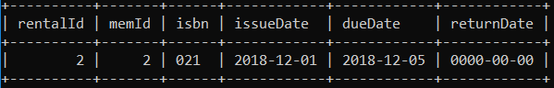

# Introduction/Overview

The aims and objectives of this system are as follows:

* Addition of new book and members
* Update books and members
* Book issue and return
* Fine payment
* A search feature to search books, categories and members

Library Management System is an application which refers to library systems which are generally small in size. It is used by librarian to manage the library using a computerized system where he/she can record various transactions like issue of books, return of books, addition of new books, addition of new members etc.

# Elements/Description/Pages

1. **books.html**

This page contains search, add, update and delete book.

|  |  |  |  |
| --- | --- | --- | --- |
| SELECT | ADD | UPDATE | DELETE |
| Takes in book isbn.  Displays the book  details. | Takes in book details.  Inserts new book into books table. | Takes in isbn.  Asks for changes.  Updates changes. | Takes in isbn.  Displays details and asks for confirmation.  Deletes member. |
| selectBook.php | addBook.php | updateformB.php | deleteB.php |
|  |  | updatedB.php | deleteBook.php |

1. **categories.html**

This page contains search book by categories feature.

|  |
| --- |
| SELECT |
| Takes in category code.  Displays the books for the corresponding category. |
| selectCategory.php |

1. **members.php**

This page contains search, add, update and delete member.

|  |  |  |  |
| --- | --- | --- | --- |
| SELECT | ADD | UPDATE | DELETE |
| Takes in member name.  Displays the member details. | Takes in member details.  Inserts new member into members table. | Takes in memId.  Asks for changes.  Updates changes. | Takes in memId.  Displays details and asks for confirmation.  Deletes member. |
| selectMember.php | addMember.php | updateformM.php | deleteM.php |
|  |  | updatedM.php | deleteMember.php |

1. **rentals.html**

This page contains rent and return book and pay fine features.

|  |  |  |
| --- | --- | --- |
| RENT BOOK | RETURN BOOK | PAY FINE |
| Takes in isbn and date.  Checks if the book is availaible on the date. | Takes in rentalId.  Asks for returnDate (default - today).  Updates the returnDate in rentals table. | Takes in memId.  Asks for fine amount you want to pay.  Updates the fine in members table. |
| selectRental.php | returnform.php | payform.php |
| addFormRental.php | confirmReturn.php | confirmPay.php |
| addRental.php |  |  |